TESTING EQUALITY OF MEANS IN PARTIALLY MATCHED DATA

**Introduction**

It is common in biostatistics to test the equality of two means. In study designs with two independent, normally distributed samples, the two-sample *t*-test is appropriate. In study designs with two *paired* samples, at least two approaches are available. First, the one-sample *t*-test can be used on the unit-level differences between the first measurement and the second measurement. Second, although less routine, the two-sample *t*-test modified for correlated data can be used, assuming the correlation coefficient is a constant (Zimmerman 2012).

Some study designs may include a hybrid of independent samples and repeated measures. For example, a subset of participants in a drug trial may be lost to follow-up, precluding the calculation of difference scores, but the remainder of participants may have pre- and post-intervention measurements available. Such designs have been called partially paired (Guo and Yuan 2017), or partially correlated (Samawi and Vogel 2014).

Recently, methods have been proposed to evaluate the equality of means in study designs with partially paired data (Lin and Stivers 1974, Samawi and Vogel 2014, Guo and Yuan 2017). Such methods involve tests based on modified maximum likelihood, multiple imputation, or pooling statistics across the paired and unpaired subsets of data.

A separate type of disconnected data called *unmatched data* arise in paired or repeated measures study designs when unit-level identifiers have been lost or withheld, sometimes in the interest of anonymity. For example, an online survey is administered anonymously to an employee pool, with each employee submitting a response before and after an intervention. The feature of this dataset that would qualify it as unmatched is the absence of any identifier that could link one employee’s response from the pre-intervention period to the same employee’s response in the post-intervention period. For convenience, we refer to such study designs as *paired but unmatched.* Study designs with paired but unmatched observations have received relatively less attention.

Data from paired but unmatched studies present a challenge for testing the equality of means. The one-sample *t*-test cannot be used, due to the inability to match samples and calculate difference scores. Using the two-sample ­*t*-test is equivalent to assuming samples are uncorrelated, which is often an unrealistic assumption of repeated measures data in biostatistics. An alternative approach involves calculating the minimum possible correlation coefficient given the observed data; this value can be used as the estimated correlation in the two-sample *t*-test modified for correlated data. However, this approach yields a maximally conservative test and is poorly powered.

In cases where even a small number of observations can be matched, an opportunity exists to construct a test for the equality of means that uses the matched pairs to inform an estimate of the correlation between all pairs. We refer to the study design in which observations are paired but only some observations are matched as *paired but partially matched,* or more concisely, *partially matched*. In this work, we show that several methods can powerfully test for the equality of means in partially matched data, while controlling Type I error rates at a nominal level.

**Methods**

*Notation / Definitions*

Let **X** and **Y** denote random variables for which we wish to compare means. Let denote the true, unobserved correlation between **X** and **Y**. We draw *n* paired samples , each of which represents a unit-level observation. Because data are paired but partially matched, we only observe matched pairs for *m* samples, and the remaining *n – m* paired samples are unmatched. For unmatched samples we cannot identify which observation in corresponds to its pair in . Our aim is to evaluate the difference in means, , between **X** and **Y**.

Assuming **X** and **Y** are normally distributed, and the variance of **X** and **Y** are equal, we have the following formula for the two-sample *t*-test modified for correlated data (Zimmerman 2012):

Note that the above statistic is equivalent to when *t* is the statistic from the two-sample *t*-test for independent variables with equally sized samples. Smaller values of result in a test statistic that is more conservative, while larger values of result in a test statistic that is more anti-conservative. Also note that applying the two-sample *t*-test in unmatched data is equivalent to setting in the above equation and thus, assuming independence of **X** and **Y**.

In most applied scenarios this test requires an estimate of , which we will denote *r*. This additional requirement may explain the relative unpopularity of the test compared to the paired-samples *t*-test (which we previously referred to as the one-sample *t*-test on differences). However, Zimmerman (2012) demonstrated that compared to the paired-samples *t*-test, the modified *t*-test can improve power in modestly sized datasets (e.g., *n* = 25) while controlling the Type I error rate near the nominal level of 0.05. This improvement in power is due to the greater degrees of freedom in the modified test statistic, compared to the paired-samples test statistic (2*n* – 2 versus *n* – 1 degrees of freedom, respectively).

In partially matched data, the challenge in designing an appropriate test for the equality of means lies in finding a reasonable estimator of the correlation, *r*, despite observing only a subset of matched pairs in the sample. We considered several candidate estimators described in the next section.

*Estimators of correlation*

*1. Maximally conservative estimator:*

One can calculate the minimum possible correlation coefficient given the observed data, which yields a maximally conservative test for the equality of means (i.e., it would result in the fewest number of rejected null hypotheses).

Let *j* denote the index of the samples sorted in ascending order. Then the following formula defines the maximally conservative estimate of the correlation:

Note that calculation of the numerator data in the above equation requires sorting observed samples from **X** in ascending order while sorting observed samples from **Y** in descending order.

Although expected to have considerable bias towards underestimating the true correlation, the above estimator is calculable even when data are unmatched. That is, when there are no matched samples with which to estimate the correlation. This is one advantage of the estimator, . The remaining estimators of correlation require at least one matched sample to be calculated.

*2. Pearson correlation of the matched samples:*

Perhaps the most intuitive correlation estimate in the presence of partially matched data uses the *m* matched samples and ignores the *n - m* matched samples. The following formula gives the Pearson correlation coefficient for matched samples:

The above estimator requires at least two matched samples to be calculable, and when only two matched samples are available, the estimator will return a value of either 1 or -1. However, with three or more matched samples we expect the above estimator to be substantially less biased than the maximally conservative estimator.

*3. Quantile estimator of the matched samples:*

Recognizing that the property of conservatism in estimating might be desirable, yet the degree of conservativism in might be too extreme, we hypothesized that a quantile estimate of might yield additional power while maintaining appropriate Type I error control.

The Fisher transformation of a Pearson correlation can be used to obtain an approximately normally distributed quantity and thus, a confidence interval for . Our estimator is constructed from the lower bound of an 80% confidence interval for the one-sided hypothesis test of a correlation between matched samples. Let be the standard error of the Fisher-transformed correlation coefficient. Then the following formula gives the quantile estimator of the correlation of *m* matched samples:

Note in the above estimator that is the critical value chosen based on a desired confidence level. Since our desired confidence level was 80%, the critical value of was 0.842, and we refer to our estimator as a 20th quantile estimator of the correlation of the matched samples, .

Our rationale behind the quantile estimator was to account for the uncertainty in when computing the two-sample *t*-test modified for correlated data. This uncertainty exists even when data are entirely matched. Zimmerman (2012) noted that in simulation, the modified *t*-test using the sample correlation did not achieve the nominal significance level that the paired-samples *t*-test achieved until sample sizes of 100 or greater. An estimator of correlation that is biased toward underestimating the true correlation will result in a more conservative test. In theory, there exists some for which the Type I error is controlled at the desired level. In practice, we selected the 20th quantile as a semi-conservative estimator that we expected to generalize in a variety of datasets.

The quantile estimator requires at least four matched samples to be calculable, due to its dependence on the confidence interval calculation, in which the denominator of the standard error is *n - 3*.

*4. Bayesian estimator of the matched samples:*

One undesirable property of the quantile estimator is its bias toward underestimating the true correlation, even when sample sizes may be large enough to warrant less conservatism. A Bayesian approach permits some conservatism in the form of shrinkage towards a prior expectation of , while also accompanying evidence from observed data.

Fosdick and Raftery (2012) presented several Bayesian estimators of correlation available for bivariate normal data with known variances and small sample sizes. We adapted the estimator based on the posterior mean assuming a Jeffreys prior by first standardizing the data to comply with the required assumption of means equal to zero and variances equal to one. The Jeffreys prior puts more weight on extreme values of correlation compared to a uniform prior.

Let and denote standardized observations. Let , , and denote quantities obtained from the *m* standardized and matched samples. Then the following formula gives the posterior mean correlation assuming a Jeffreys prior:

Note that standardizing the data may be achieved with both matched and unmatched samples. However, the above estimator requires at least one matched sample to be calculable.

*5. EM Algorithm estimator of correlation:*

The EM algorithm offers a general approach to obtaining maximum likelihood estimates under incomplete data scenarios (Dempster, Laird and Rubin 1977). In the case of partially matched data, the quantity is incompletely observed due to the inability to match all samples and calculate the cross product.

However, the missing quantity can be partitioned into an observed quantity, , and an unobserved quantity assuming the first *m* samples are matched. The latter quantity has a defined expectation when the parameters of the bivariate normal distribution are known (e.g., ).

Note that maximum likelihood estimates of can be obtained regardless of whether data are matched or unmatched. Our implementation of the EM algorithm iteratively updates the expectation of and the maximum likelihood estimate of until convergence. At least one matched sample is required for valid estimates of the correlation.

*Simulation study*

Data were simulated from bivariate normal distributions and from bivariate ordinal distributions. The latter were obtained by ‘binning’ values of the normal distribution to derive a seven-level ordinal variable. Bins were selected to yield a right-skewed ordinal distribution to mimic the empirical distributions in our application.

We specified the following values of true correlation to simulate data: -0.9, -0.5, -0.25, 0, 0.25, 0.5, and 0.9. Note that for the ordinal distribution, the true correlation was not preserved due to the transformation from a continuous space to an ordinal space. However, we estimated the following effective correlations for ordinal data, based on simulation: -0.58, -0.36, -0.19, 0, 0.20, 0.43, and 0.84 (respectively for each successive value of the bivariate normal correlation).

Samples sizes of 10, 20, 50, 100, and 200 were generated. The proportion of matched samples varied from 0 to 1, to simulate varying conditions of the partially matched data problem. True mean differences of 0, 0.25, and 0.5 were generated. We fixed the variances of both variables to one, although in ordinal data we noted this resulted in effective variances of 2.2.

We simulated 10,000 datasets for every combination of the above simulation parameters (resulting in 16.8 million datasets). For each of the five estimators of correlation mentioned previously, we monitored bias and mean squared error. We derived the two-sample *t*-test modified for correlated data using each of the estimators and monitored Type I error rates (when the true mean difference was zero) and power (when the true mean difference was 0.25 or 0.5). We compared estimators to one another, as well as against the naïve approach of assuming independence, and against an ’oracle’ approach in which the true correlation was known.

*Application*

Our application is a dataset containing ordinal survey responses from 149 physicians before and after an educational intervention, of which 19 physicians had matched pairs. We ran tests for the equality of means between the pre- / post- intervention groups, using the modified *t*-test, with each of the correlation estimators evaluated in the simulation study.

**Results**

*Simulation study*

Not all estimators yielded a valid correlation, particularly when the number of matched samples was small (i.e., less than four) and the generating distribution was ordinal.

For normally distributed data with a sample size of 20 and four matched samples, the Pearson correlation of the matched samples (rmatched) was the least biased estimator across all values of correlation. The EM algorithm estimator (rEM) was slightly more biased than rmatched, followed by the Bayesian estimator (rBayes). All three of these estimators were biased toward overestimating the correlation when negative and underestimating the correlation when positive. Additionally, the 20th quantile estimator (rq20) was consistently biased toward underestimating the correlation and was least biased when the true correlation was 0.9. When the number of matched samples was reduced from four to two, there was considerably less separation among rmatched, rEM, and rBayes in terms of bias (rq20 was not calculable due to insufficient matched samples).

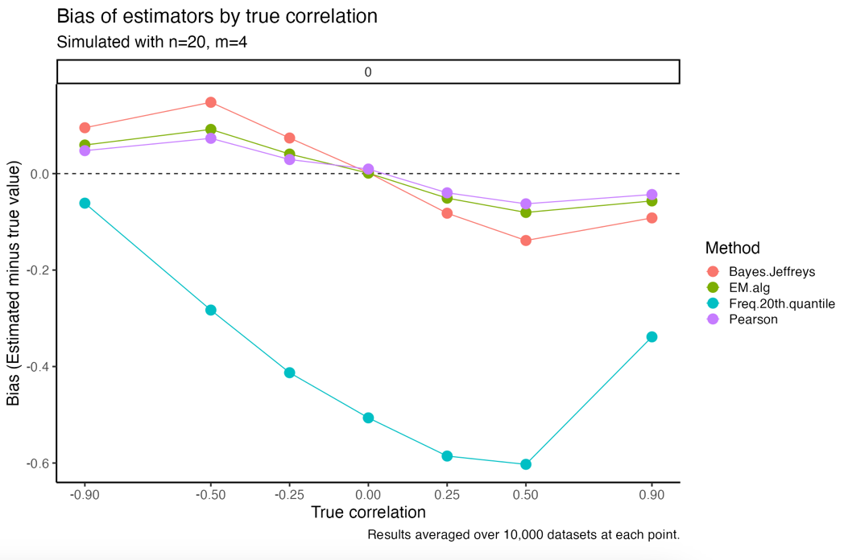

There was generally an inverse relationship between bias and mean squared error (MSE). For normally distributed data with a sample size of 20 and four matched samples, the Bayesian estimator (rBayes) was overall lowest in MSE except at extreme values of correlation. The EM algorithm estimator (rEM) trailed behind rBayes with slightly greater MSE at all but the most extreme values of correlation. The Pearson estimator (rmatched) trailed behind both former estimators. These differences persisted even as the number of matched samples was reduced from four to two. The 20th quantile estimator (rq20) was asymmetrically more variable when the true correlation was positive, and less variable when the true correlation was negative.

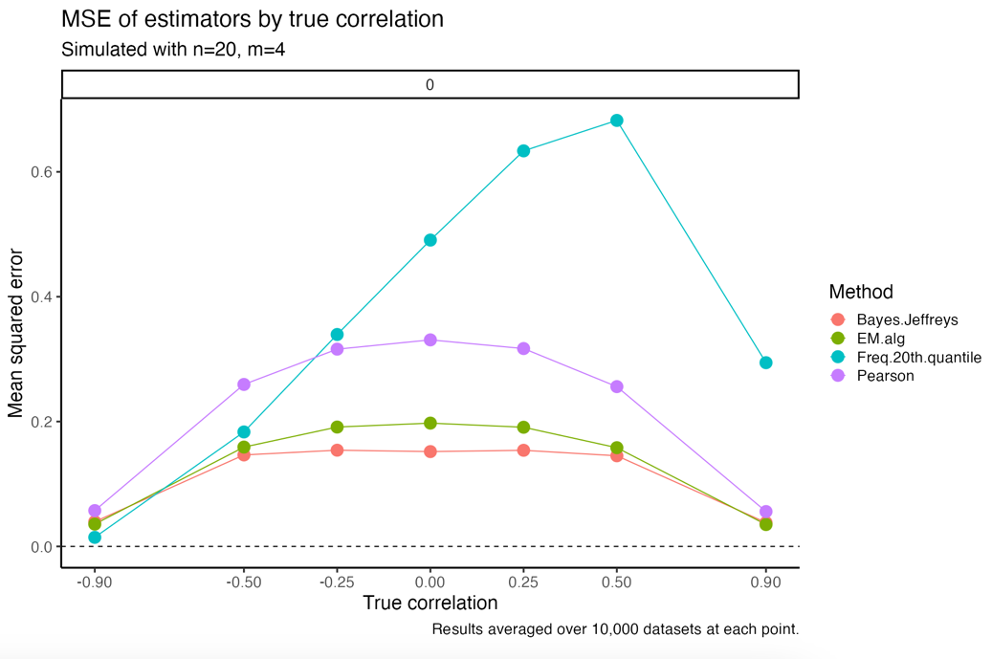

When comparing the Type I error rate among tests computed with each of the estimators of correlation, the 20th quantile estimator (rq20) was more conservative. With normally distributed data, a sample size of 20, and four matched samples, rq20 controlled Type I error near the nominal level of 0.05 across all values of correlation. The Bayesian estimator (rBayes) yielded a test that was generally less conservative than the nominal level, but far more conservative than the Pearson estimator (rmatched) for all values of correlation greater than -0.25. The same was true of the EM algorithm estimator (rEM), although rEM was slightly less conservative than rBayes. There was a direct relationship between the magnitude of the true correlation and the Type I error of the Pearson correlation estimator (rmatched). When the true correlation was positive, this test rejected the null hypothesis at least 10% of the time, which was twice the nominal rate.

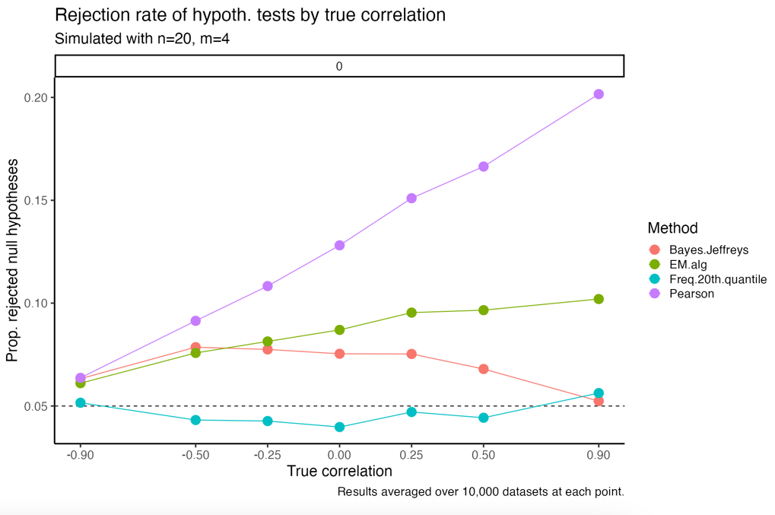

There was generally a trade-off between Type I error control and power. With the same simulation settings mentioned in the previous paragraph (bivariate normal, n=20, m=4), the Pearson correlation (rmatched) afforded the most power, although the improvement in power was smaller when the true mean difference was 0.5 standardized units. The 20th quantile estimator (rq20) demonstrated the least power among the four estimators (although the maximally conservative estimator was underpowered compared to all estimators).

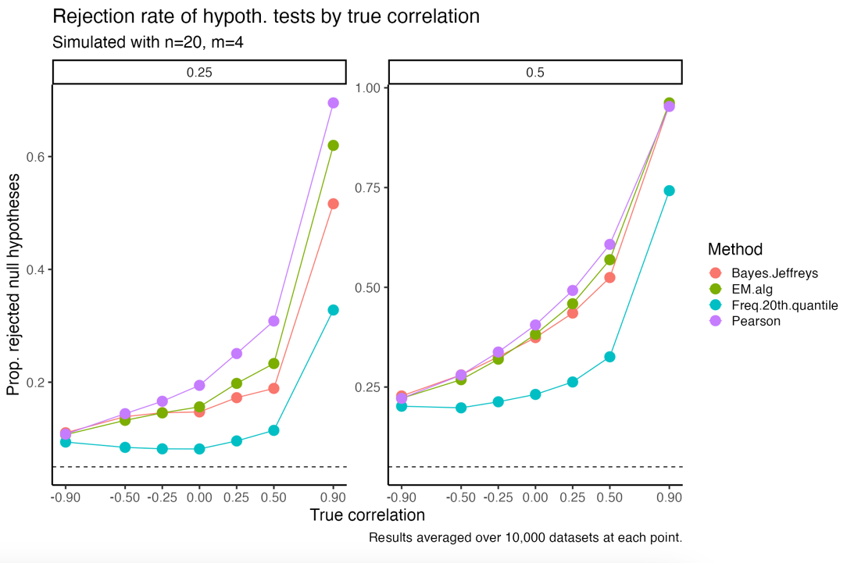

The relative conservatism exhibited in the test with the 20th quantile estimator can be attributed to reduced precision. The following plot presents standard errors (averaged over all simulations) for the various estimators. We observed that rq20 yielded the least precision among the four estimators.

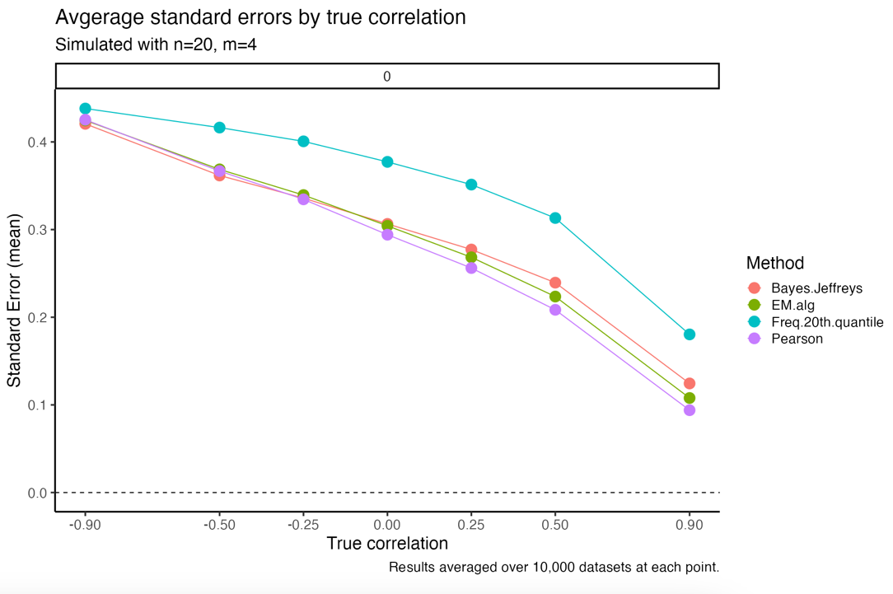

**Discussion**

We aimed to identify a test for the equality of means that can improve upon available methods for partially matched data, i.e., the two-sample *t*-test or the maximally conservative test. We have shown in that in small samples with only two matched pairs, the approach based on the EM algorithm estimator of correlation yields a test that is better powered, and consistent in controlling Type I error (albeit not at the nominal level), compared to the two-sample *t*-test, provided the true correlation is non-negative.

Although methods exist for finding the maximum likelihood estimates of the bivariate normal distribution with missing data, the focus has primarily been on cases where data are missing due to dropout (Dahiya and Korwar 1980). Our case does not involve the same mechanism of missingness, since we do not assume dropout but we assume missing identifiers.

We have also shown that in such small sample cases, the test based on the EM algorithm estimator is more consistent in controlling Type I error than the test based on the Pearson correlation estimator. This is particularly relevant, since the natural choice of an estimator for partially matched data may be the Pearson correlation, even in extremely small samples. But the EM algorithm estimator is substantially lower in MSE compared to the Pearson in partially matched data. This is likely since the EM approach considers information beyond the matched samples alone. Also of concern is the fact that using the Pearson correlation resulted in a test that was increasingly less conservative as the true correlation increased (similarly, less powered as true correlation increased).

In partially matched data we have shown that better methods exist for testing the equality of means, compared to assuming independence or using the Pearson correlation of the matched samples.

We acknowledge that a fully Bayesian approach might be desirable, for example one that posits priors for all five parameters of the bivariate normal distribution. Such an approach has been successful for developing a Bayesian alternative to the *t­*-test (Kruschke 2013). However, partially matched data make the computation of the likelihood intractable, since at least some of the paired samples cannot be matched and the cross product is incompletely observed. Instead, we have incorporated Bayesian ideas using the estimator , which posits a prior for the true correlation.

Recommendations:

* When Type-I error is the primary concern, the quantile estimator offers conservatism
* When Type-II error is the primary concern, Bayesian and EM algorithm are both well powered
* Bayesian estimator offers reasonable balance of Type-I error control and power
* Bayesian, EM, and Quantile are all clear improvements over assuming independence (much more consistent in Type-I error and power)
* No method as conservative as the maximally conservative estimator
* Pearson correlation has severe Type-I error inflation for all correlations greater than -0.25